Experiment 01
Aim: Demonstrate inline, internal, and external JavaScript; use console methods; create a webpage showing user info and a welcome message.
Software/Tools Required: HTML5, CSS3, JavaScript, VS Code , Google Chrome
Theory: JavaScript can be included in a web page using inline, internal, and external methods. Inline JavaScript is written directly within HTML elements, internal JavaScript is placed inside the
Output:
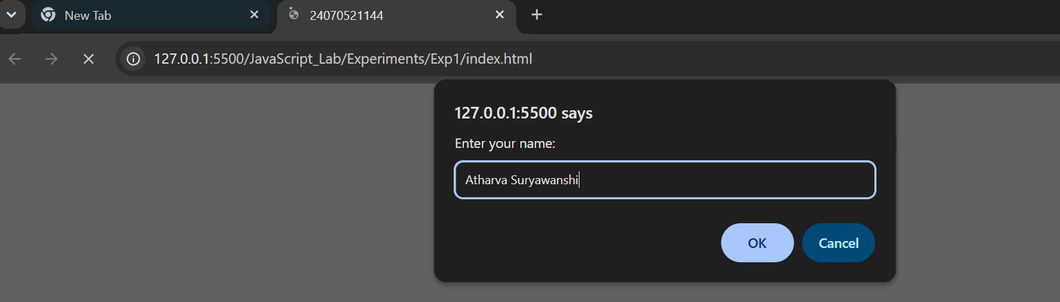
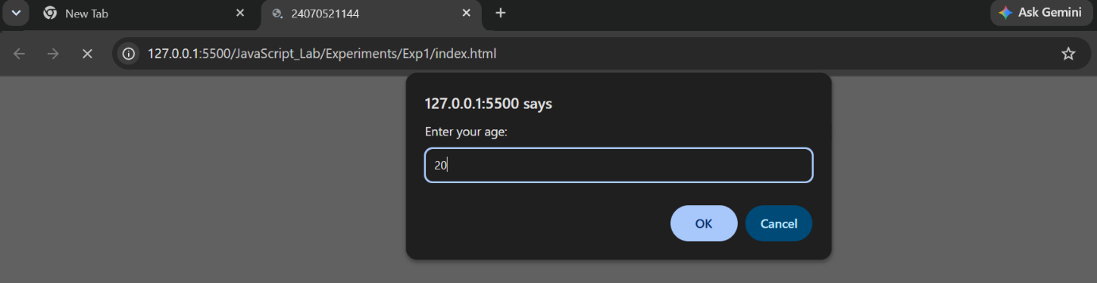
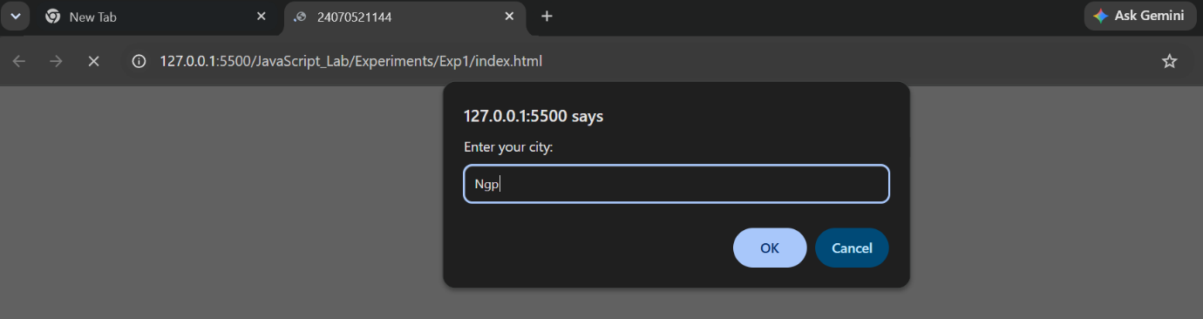
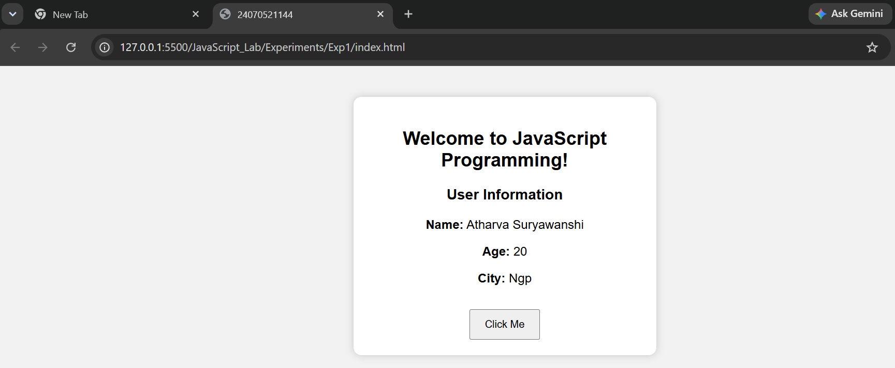
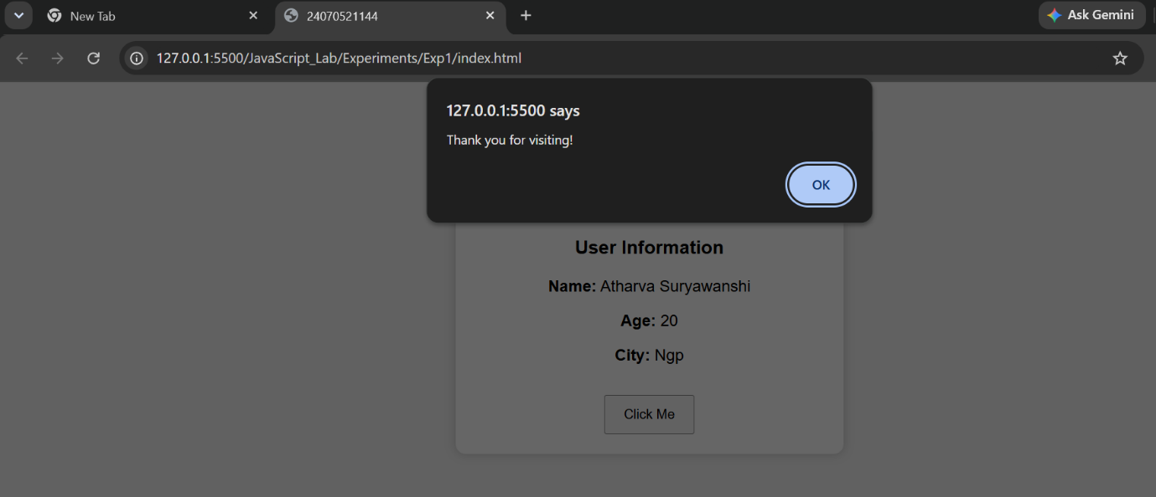

Result: The webpage was successfully created using inline, internal, and external JavaScript. It displayed a welcome message, accepted user information through input prompts, and demonstrated various console methods such as console.log(), console.info(), console.warn(), console.error(), and console.table() for debugging and output.

Case Study 01
Aim: Create a webpage for college department and link the student information page with it and write a javascript program to display “Welcome to SIT Nagpur” in an alert box.
Program Code:
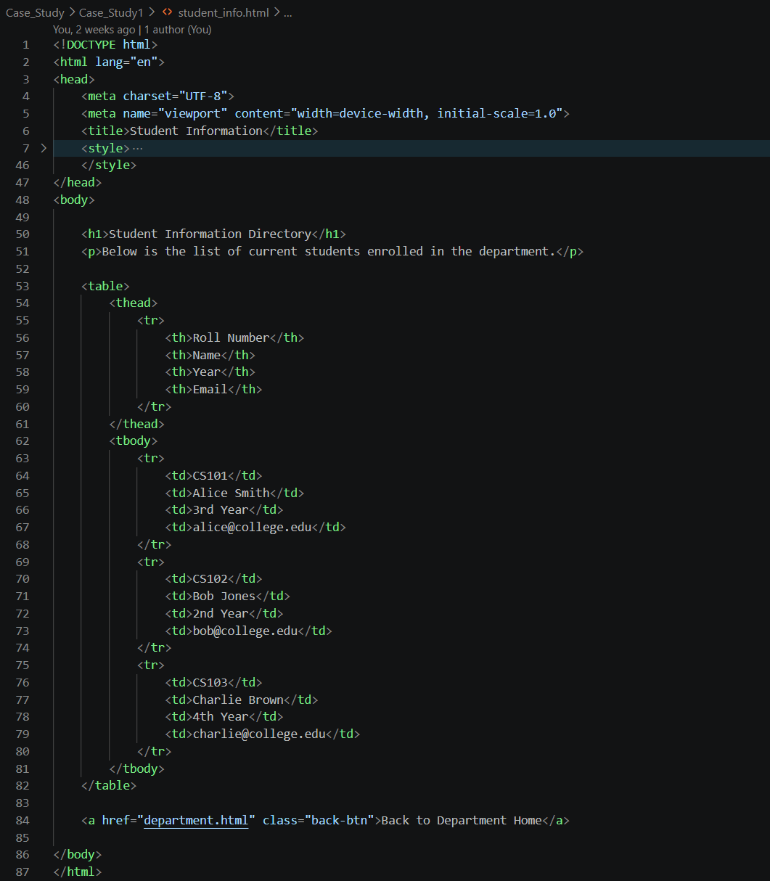

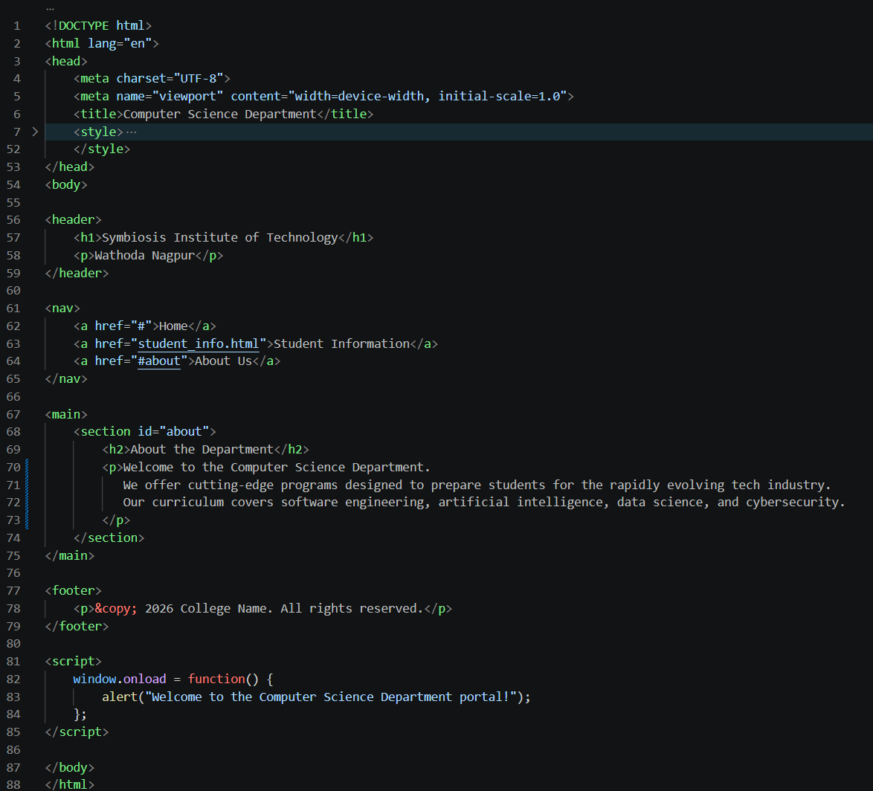
Output:
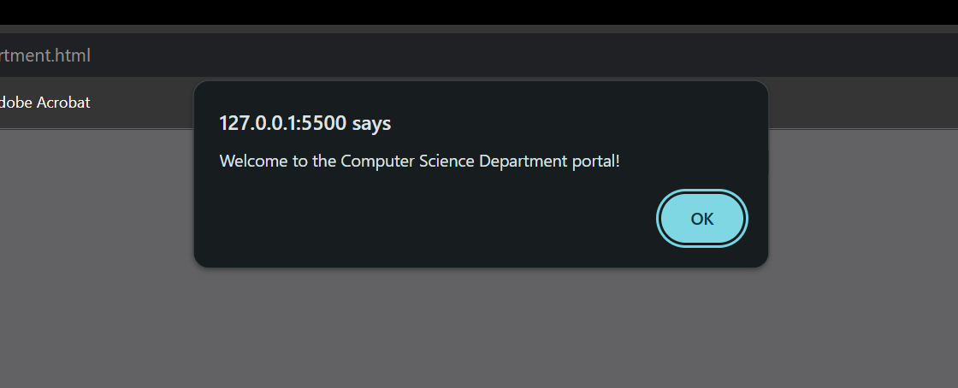
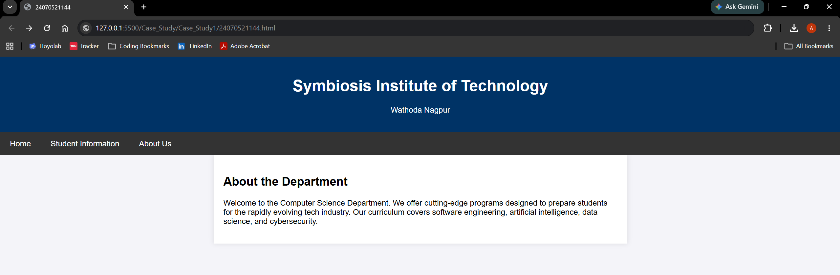

Result: A webpage for the college department was successfully created using HTML, CSS, and JavaScript. Student information was linked and displayed correctly, and the JavaScript program successfully displayed the message "Welcome to SIT Nagpur" on the webpage. Thus, the aim of creating a college department webpage and implementing JavaScript functionality was achieved successfully.

Experiment: 02
Aim: Use var, let, const, and demonstrate basic features like template literals and destructuring; build a billing calculator with user input.
Software/Tools Required: HTML5, CSS3, JavaScript, VS Code , Google Chrome
Theory: JavaScript provides var, let, and const for declaring variables with different scopes and behaviors. It also supports modern ES6 features such as template literals for easy string formatting and object destructuring for extracting object properties into variables. The prompt() function is used to accept input from the user. In this experiment, these features are used to develop a billing calculator that accepts product details, calculates the subtotal, GST (18%), and total amount, and displays a formatted bill dynamically on the web page.
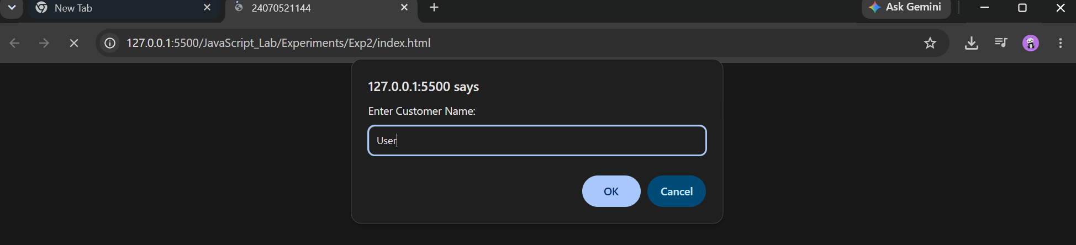
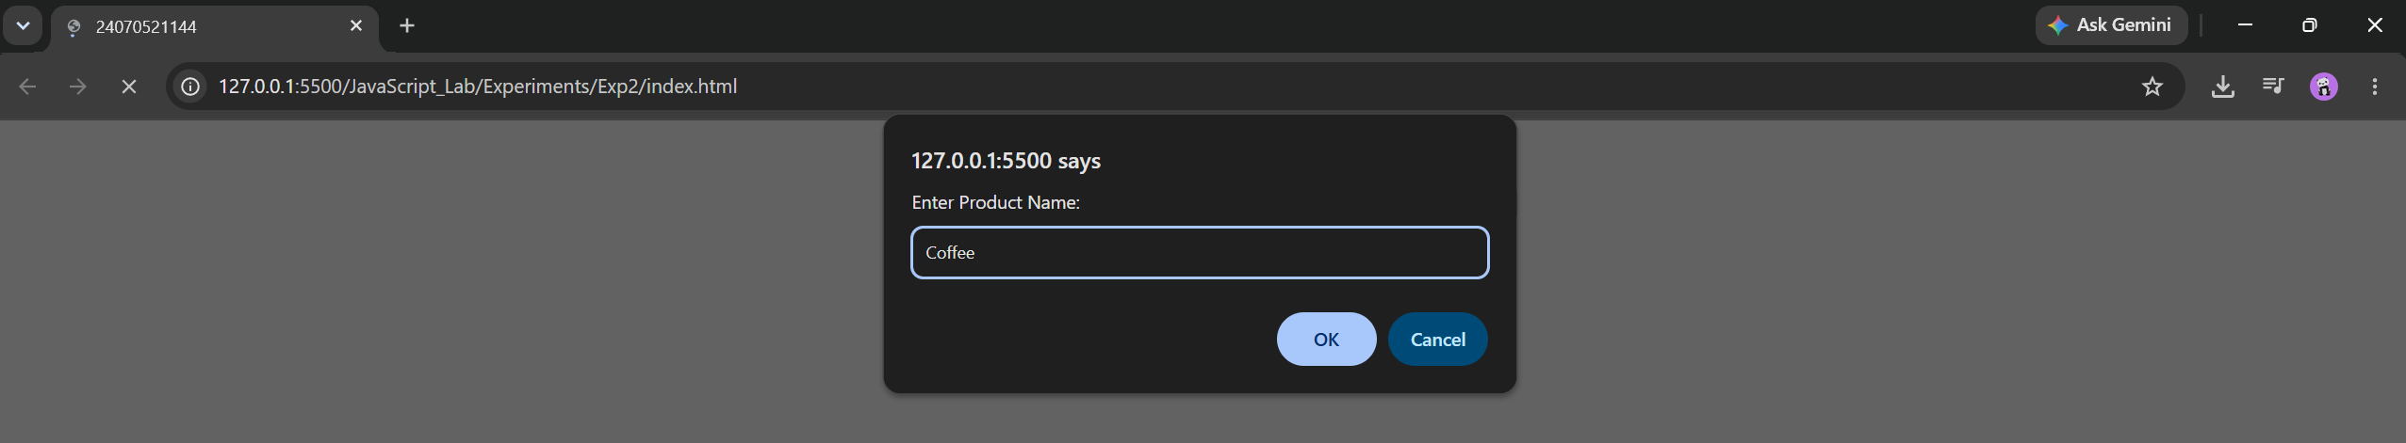
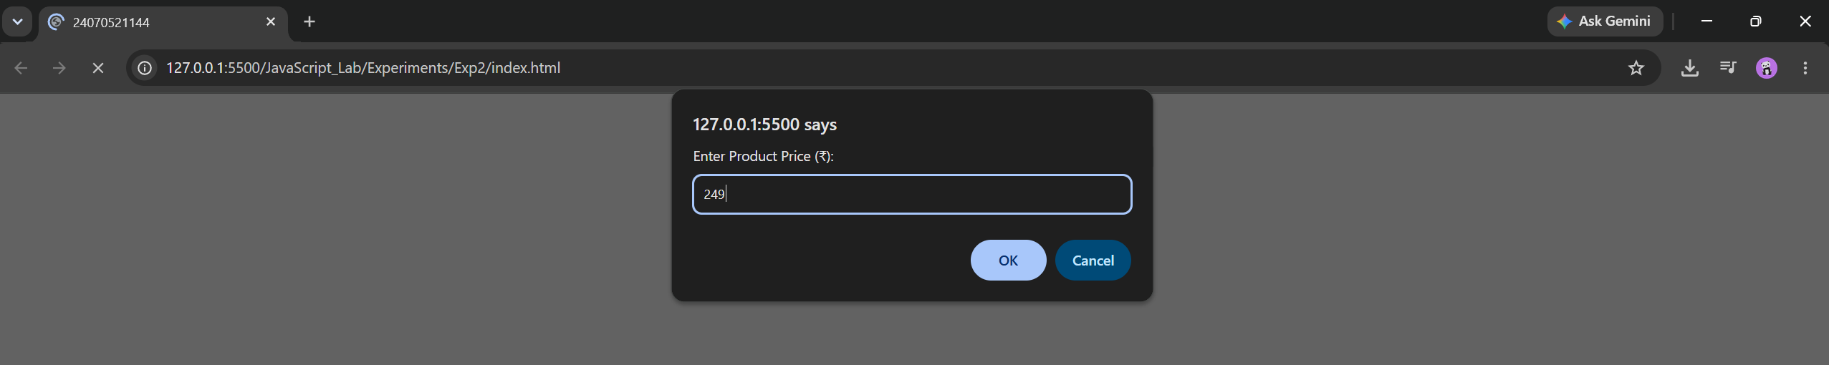
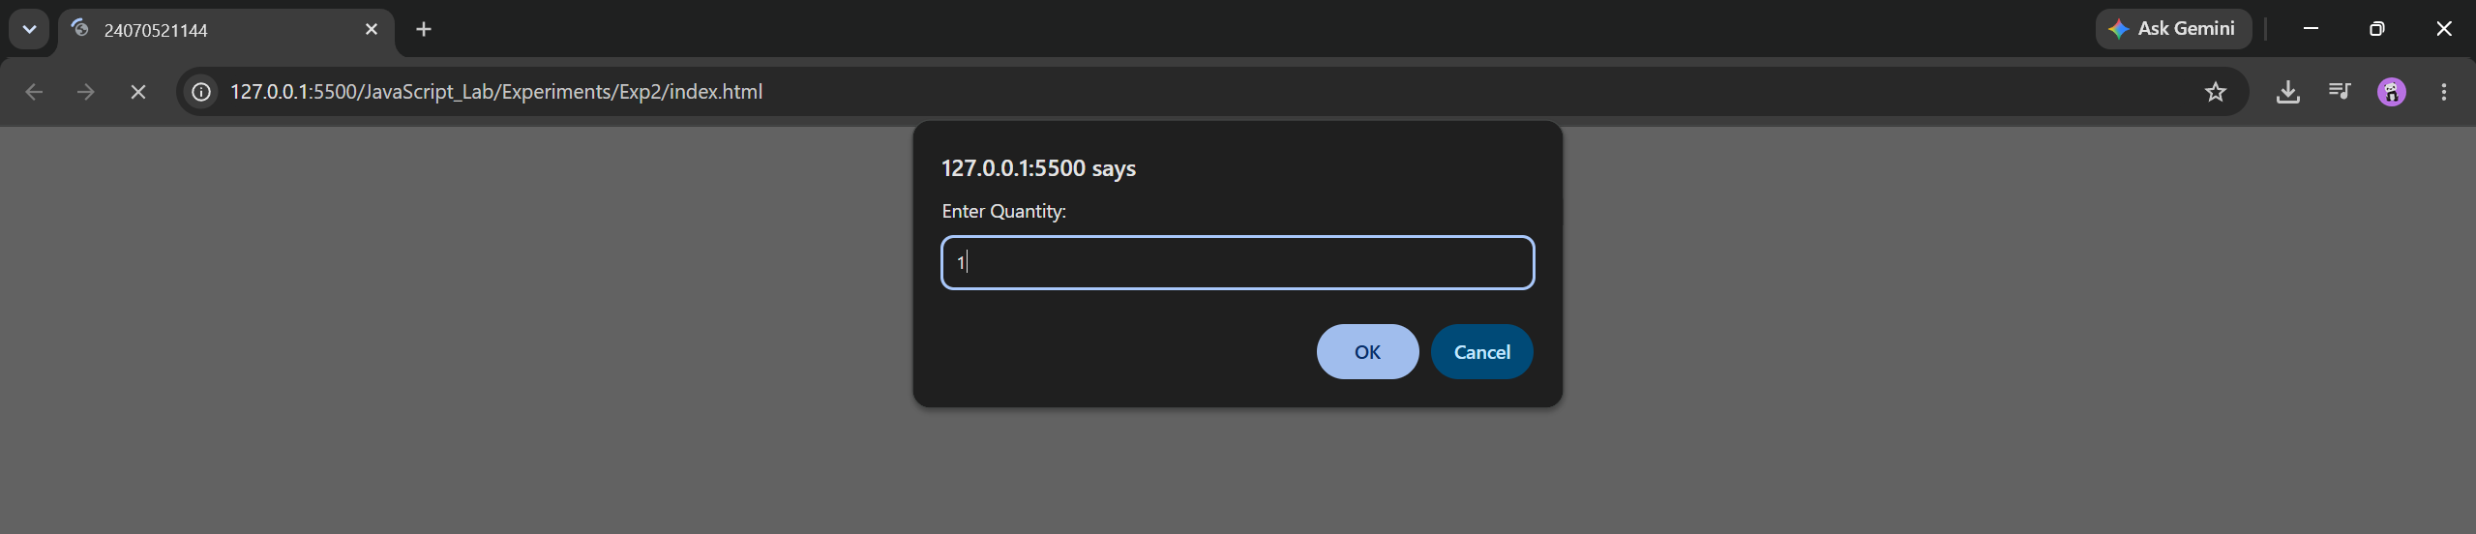

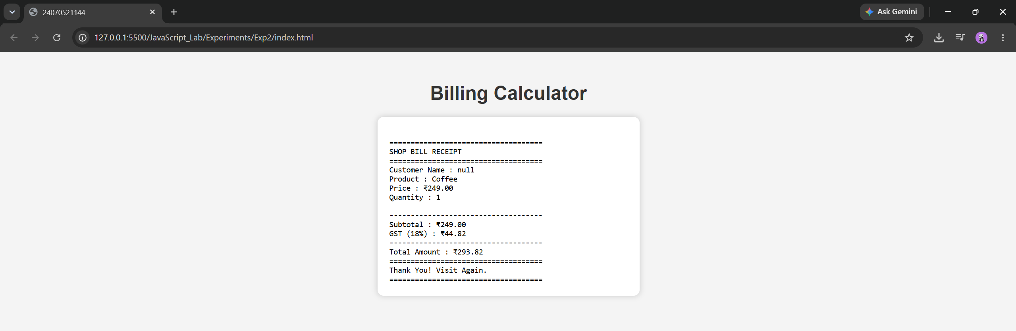

Result : The billing calculator was successfully developed using JavaScript. It accepted user input for the customer name, product details, price, and quantity, calculated the subtotal, GST (18%), and total amount, and displayed a well-formatted billing receipt on the web page.

Case Study 02
Aim: Develop the webpage for an inline shopping website with using html, css and html tags and calculate the bill, customer name, mobile number, invoice number, product number, quantity(kg), rate per kg, discount, GST, packing charges, payment mode(cash/card/UPI), membership(yes/no)
Program Code:
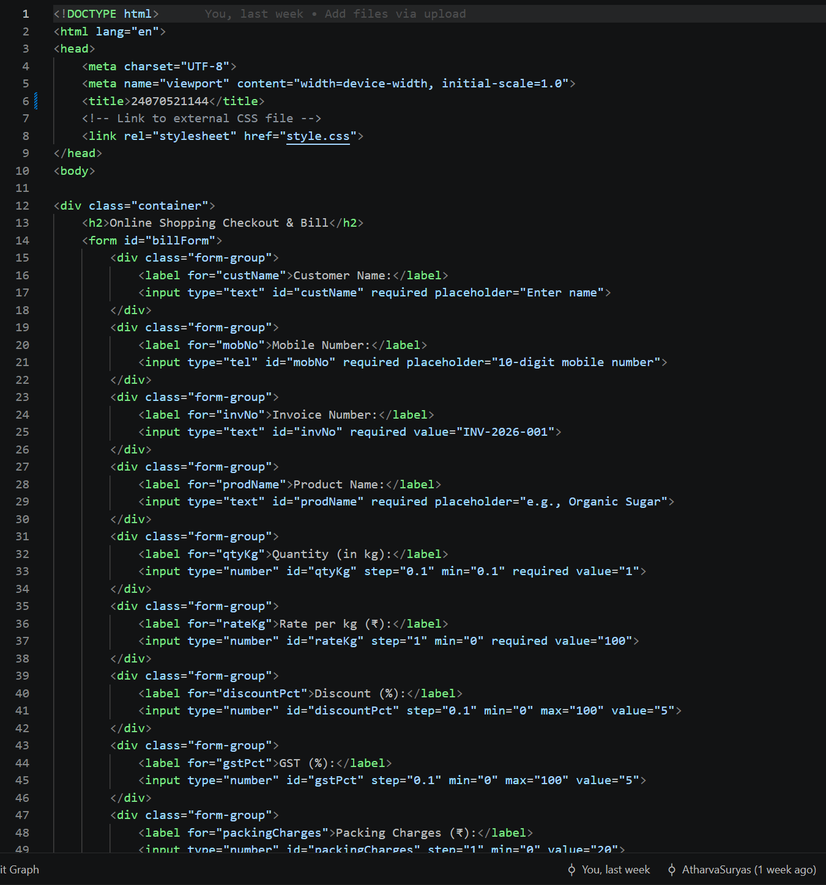

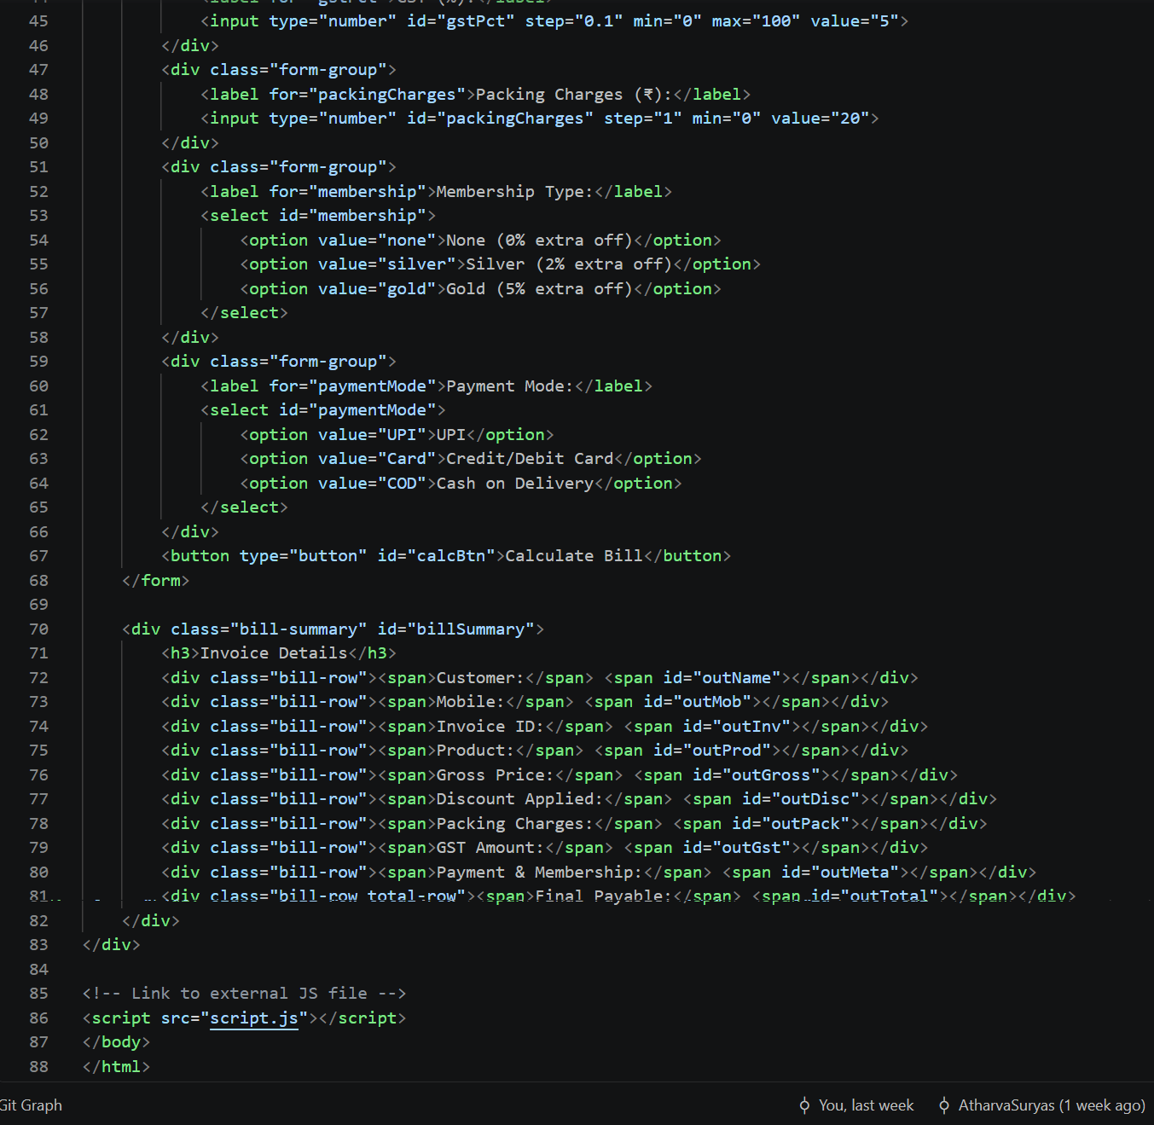

Output:
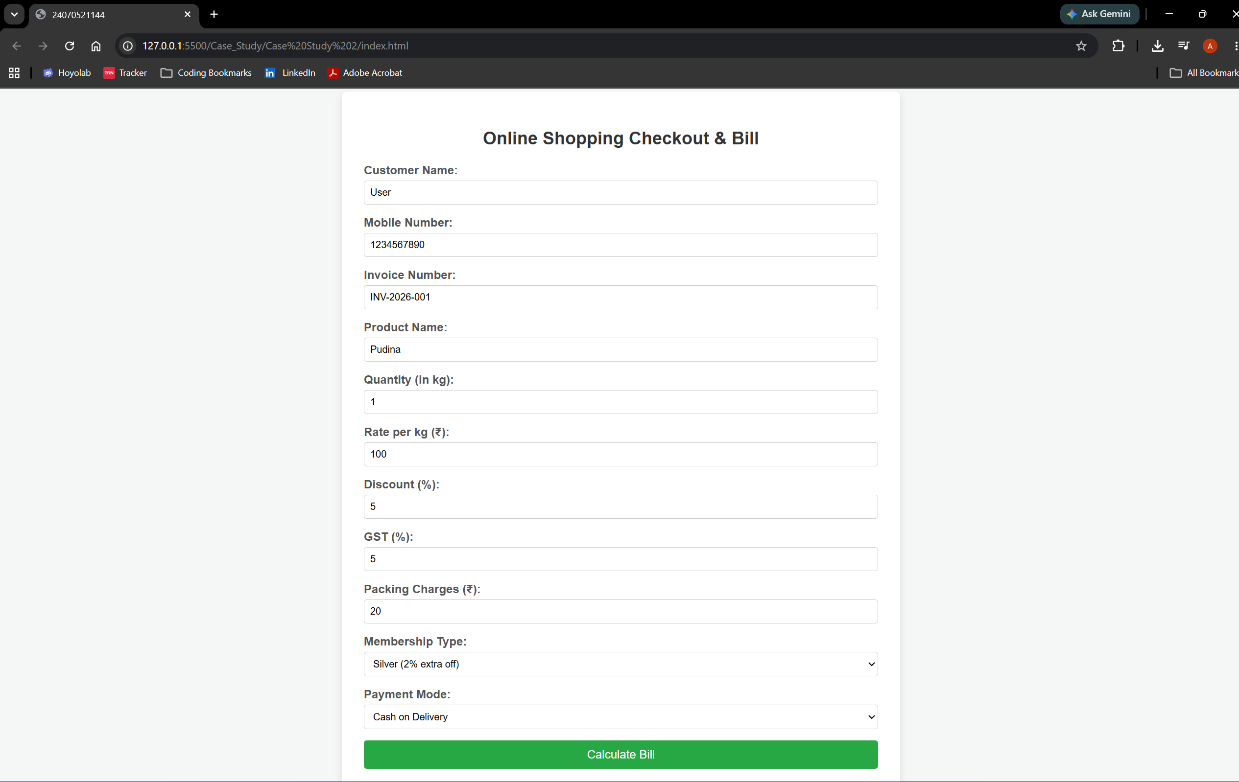
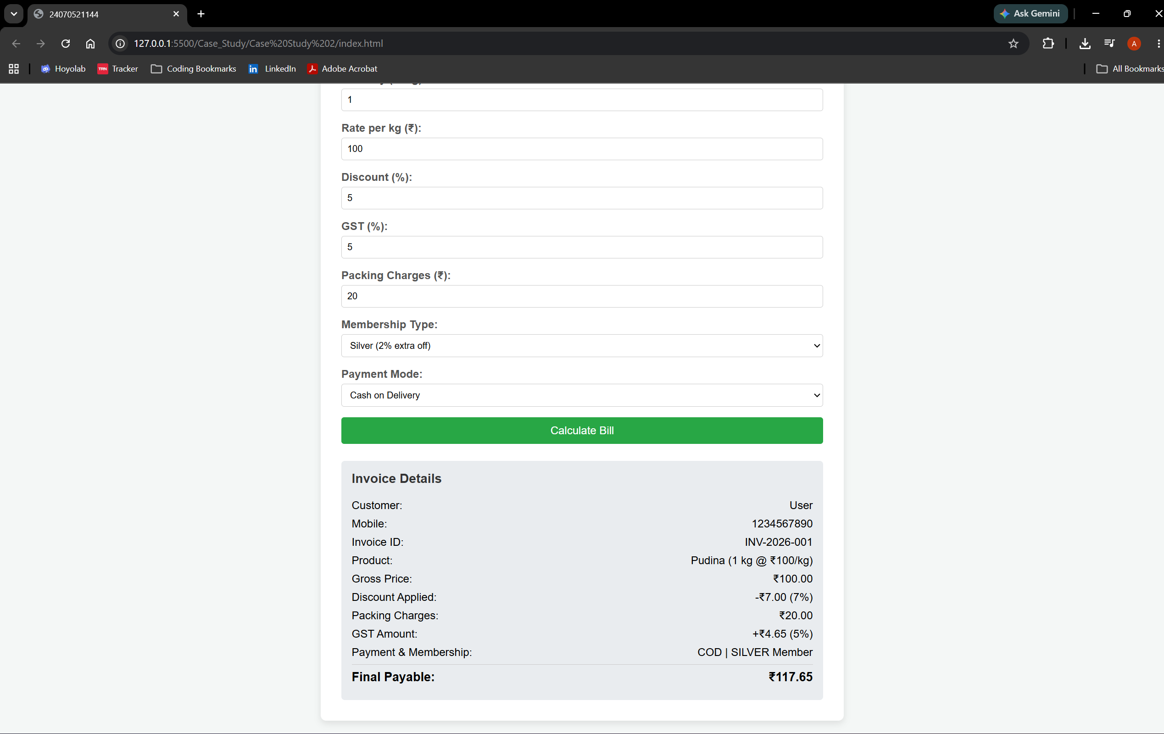

Result: The online shopping billing webpage was successfully developed using HTML, CSS, and JavaScript. The program accepted customer and product details, calculated the total bill including discount, GST, and packing charges, and displayed the final invoice correctly. It demonstrated the use of user input, arithmetic calculations, objects, template literals, and object destructuring in JavaScript.

Experiment No: 03
Aim: Implement control structures and form validation, create a grading system based on user entered marks
Software/Tools Required: HTML5, CSS3, JavaScript, VS Code , Google Chrome
Theory: JavaScript provides essential control structures, including conditional statements (if, else if, else, and switch) and loops (for, while, and do-while), to manage program execution based on dynamic conditions. These structures enable developers to build interactive features such as form validation, which checks and sanitizes user input on the client side before submission to prevent invalid or incomplete data. Additionally, JavaScript interacts with DOM elements to extract input values, process business logic—such as evaluating numeric ranges to assign grades—and dynamically display results on the web page. In this experiment, control structures and form validation techniques are applied to capture student marks, validate the input, dynamically calculate a grade, and display the formatted outcome to the user.

Output:
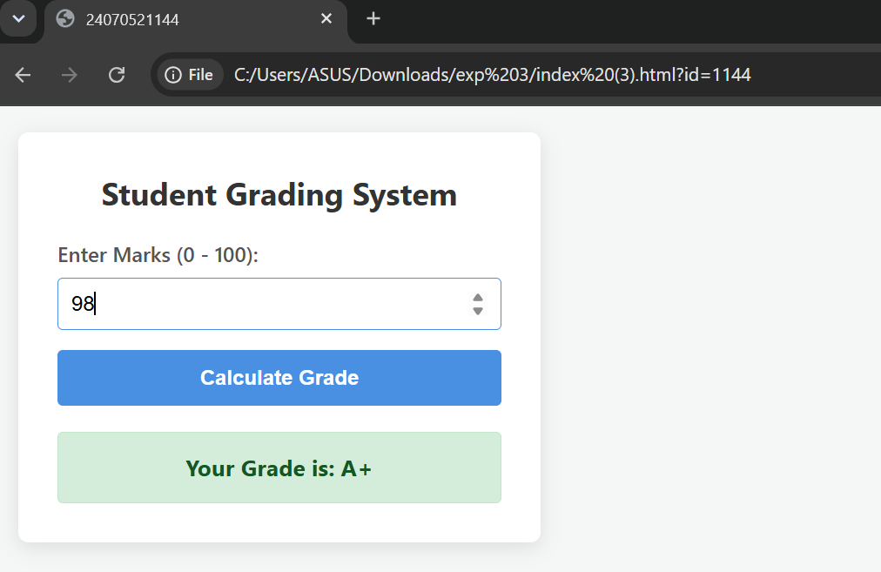

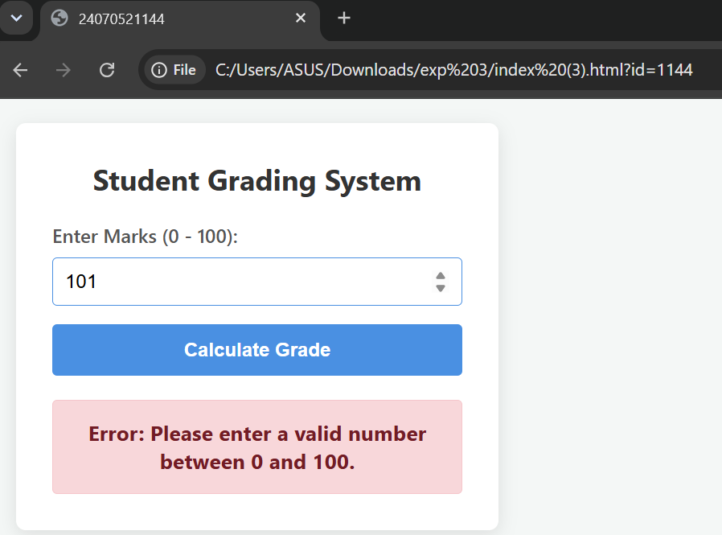

Result:
The JavaScript-based control structures and form validation system were successfully implemented and tested. The application correctly validates user-entered marks, ensuring input fields are non-empty, numeric, and fall within the valid range of $0$ to $100$. Upon validation, the control logic evaluates the entered score against predefined grading criteria and dynamically displays the corresponding grade along with feedback directly on the web page.

Case Study 03
Aim: Scholarship Eligibility,A college awards scholarships based on marks. Below 50-Not Eligible, 50-69-Bronze,70-84-Silver,85-94-Gold,95-100-Platinum.
Program Code:
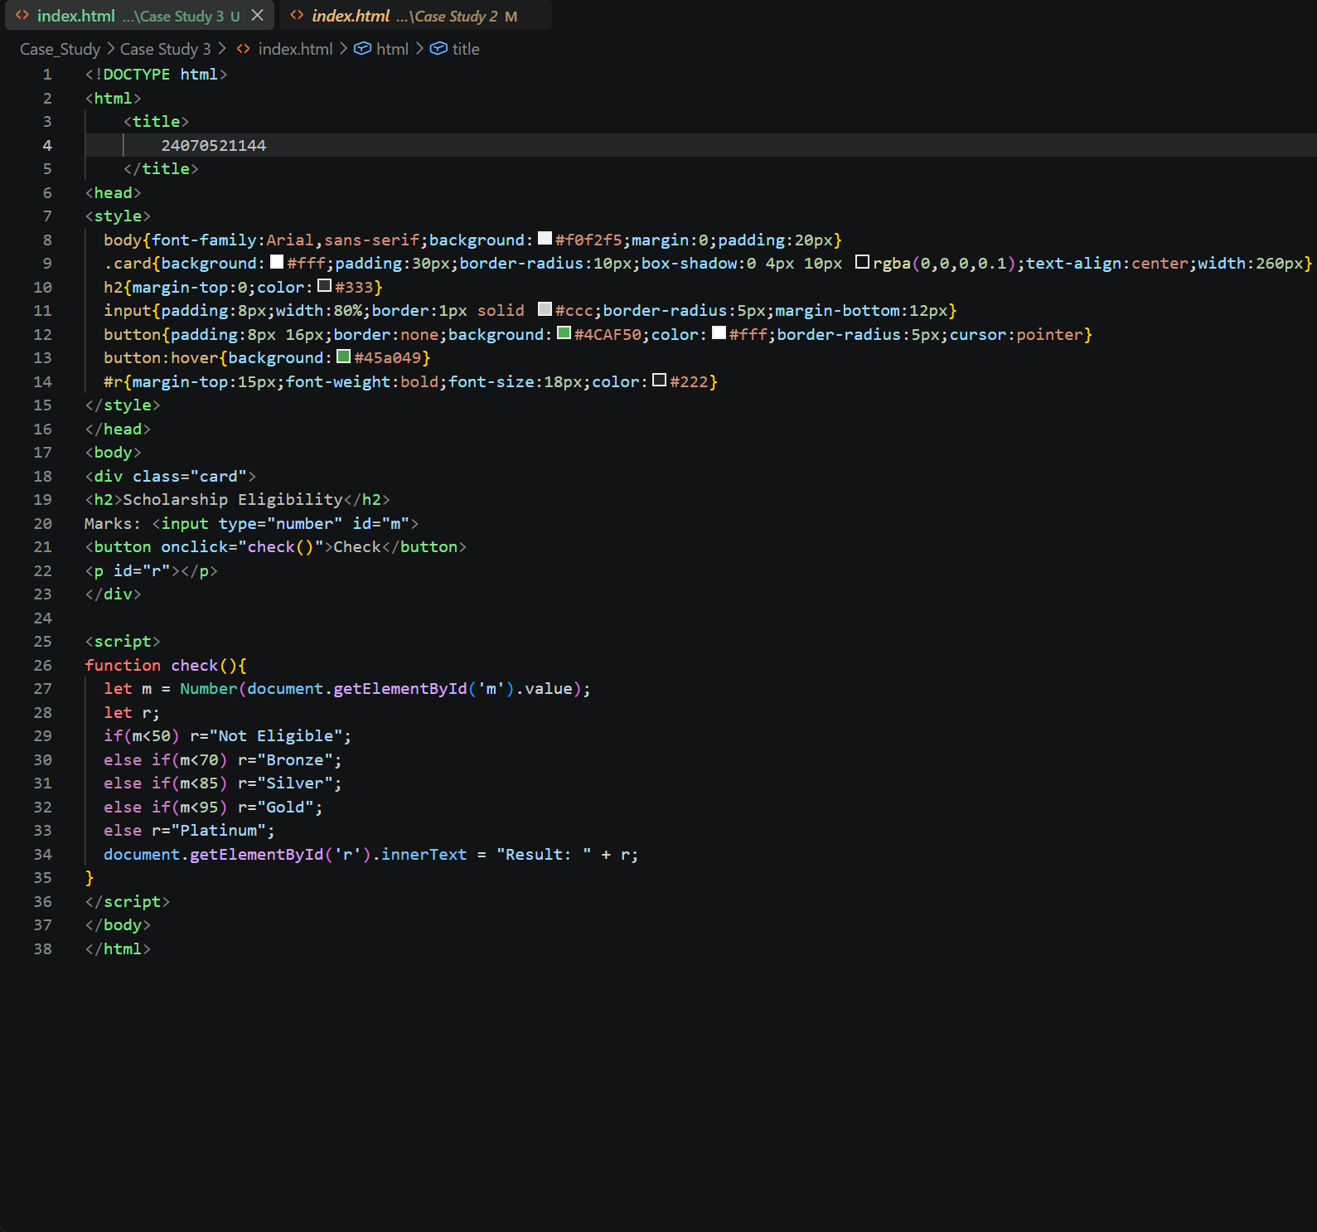

Output:
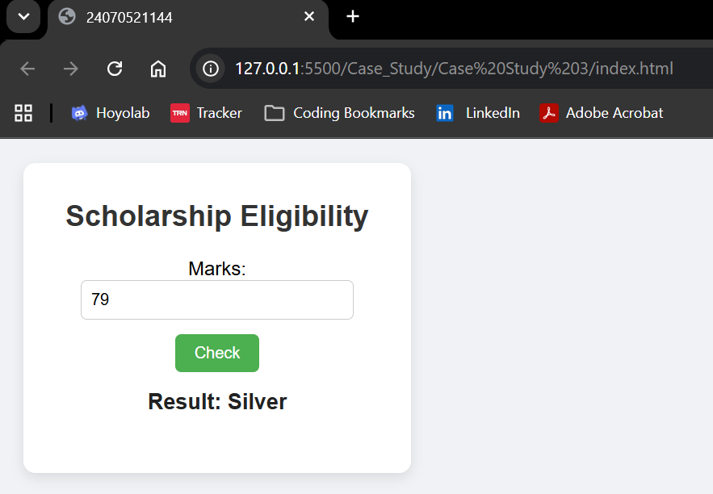

Result: The Scholarship Eligibility was successfully implemented using JavaScript. The program validated the user input, assigned eligibility marks using if-else control structures, and displayed the correct Eligibility awards based on the entered marks. It effectively demonstrated the use of control structures and form validation in web development.

Experiment 04
Aim: Use function types, scope and closures; apply try-catch; build a palindrome checker
Software/Tools Required: HTML5, CSS3, JavaScript, VS Code , Google Chrome
Theory: A palindrome is a word, number, or sentence that reads the same forward and backward, such as MADAM, LEVEL, and 121. A palindrome checker is a program that checks whether the given input is a palindrome or not by comparing the original string with its reverse.
In JavaScript, different types of functions, such as function declarations, function expressions, and arrow functions, can be used to implement the palindrome checker. Variable scope determines where variables can be accessed in the program, while closures allow an inner function to access variables from its outer function.
The try-catch statement is used for exception handling and helps manage errors, such as invalid or empty input, without stopping the execution of the program. Thus, a palindrome checker demonstrates the concepts of functions, scope, closures, and error handling in JavaScript.
Output:
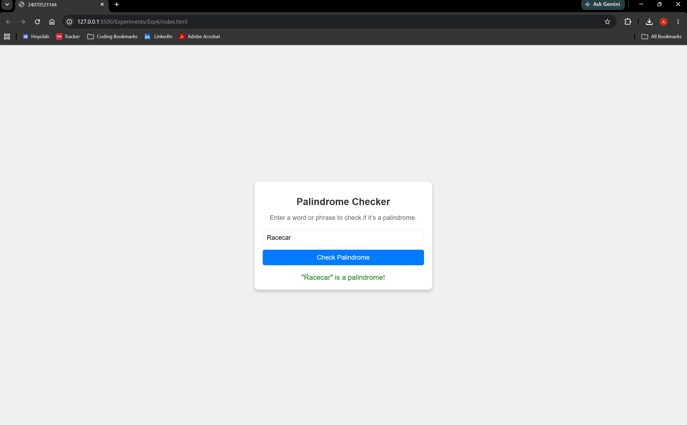

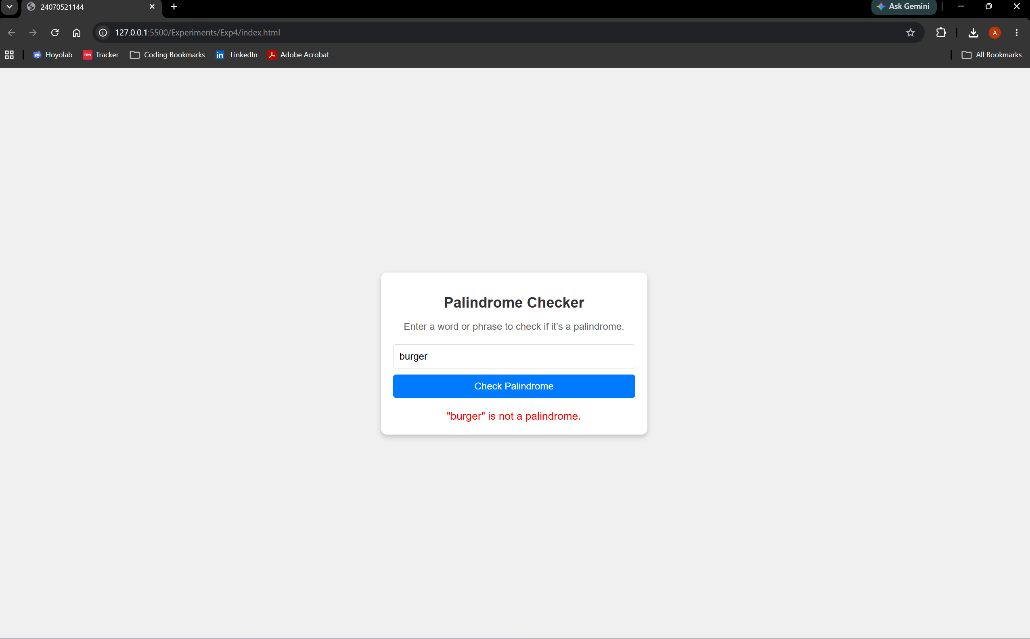

Result: Successfully implemented a Palindrome detector using JavaScript ES6 features, including var, let, const, template literals, and destructuring, to find and display whether the given text or number is a palindrome or not.

Case Study 04
Aim: The ATM system verifies if the pin is palindrome. If the palindrome displays a security message. To implement this create a function to reverse the entered pin number and another function to check if it is palindrome. use function declaration, function expression, arrow function and demonstrate scope and closure concepts.
Program Code:
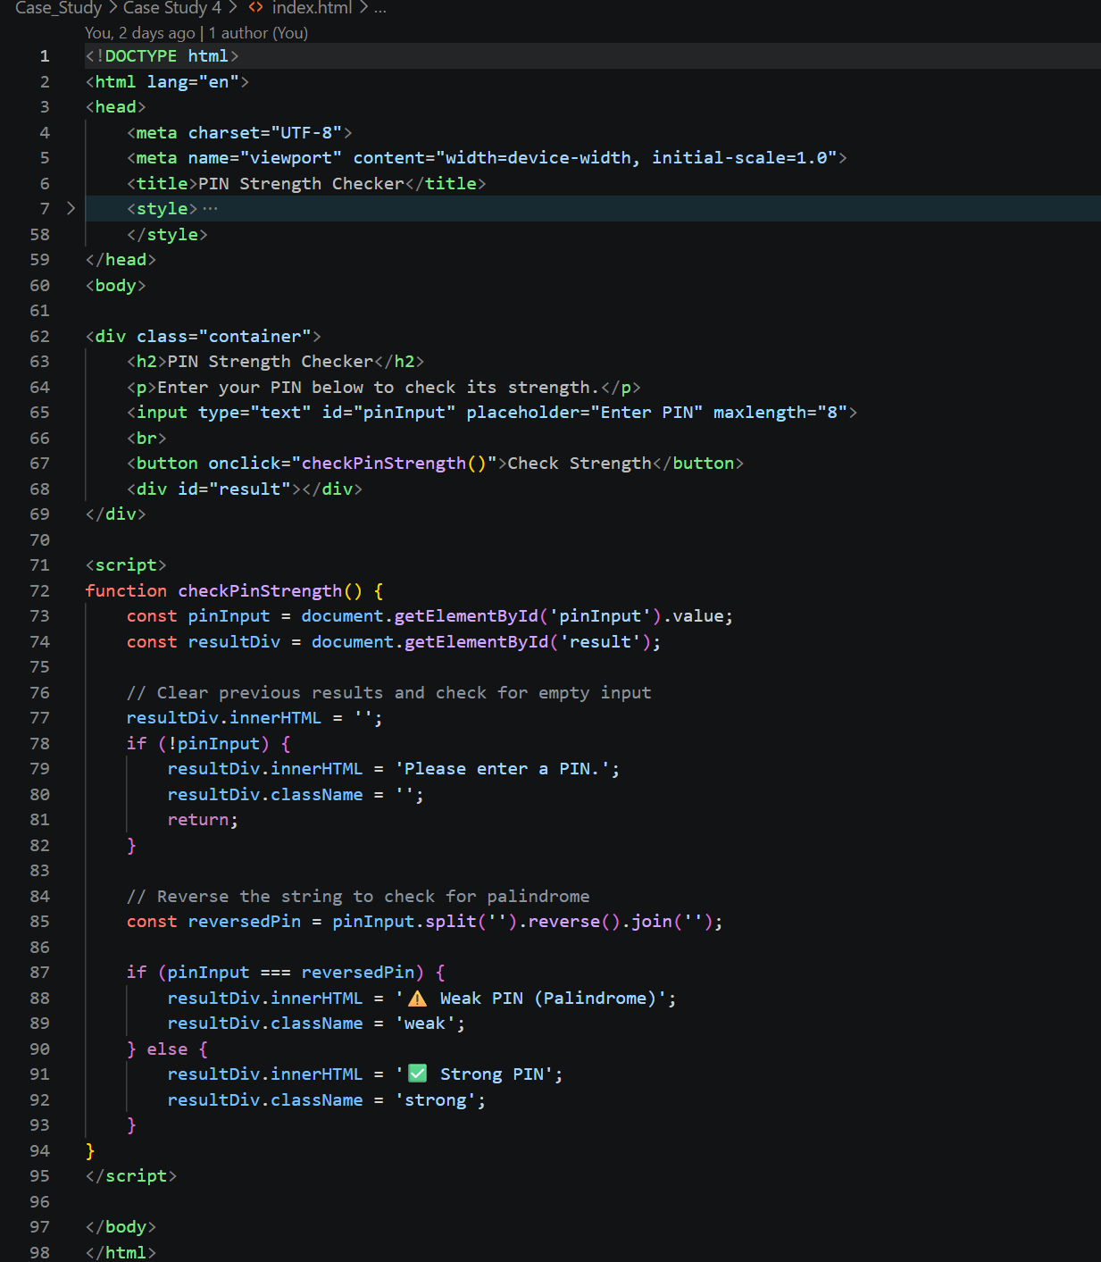
Output:
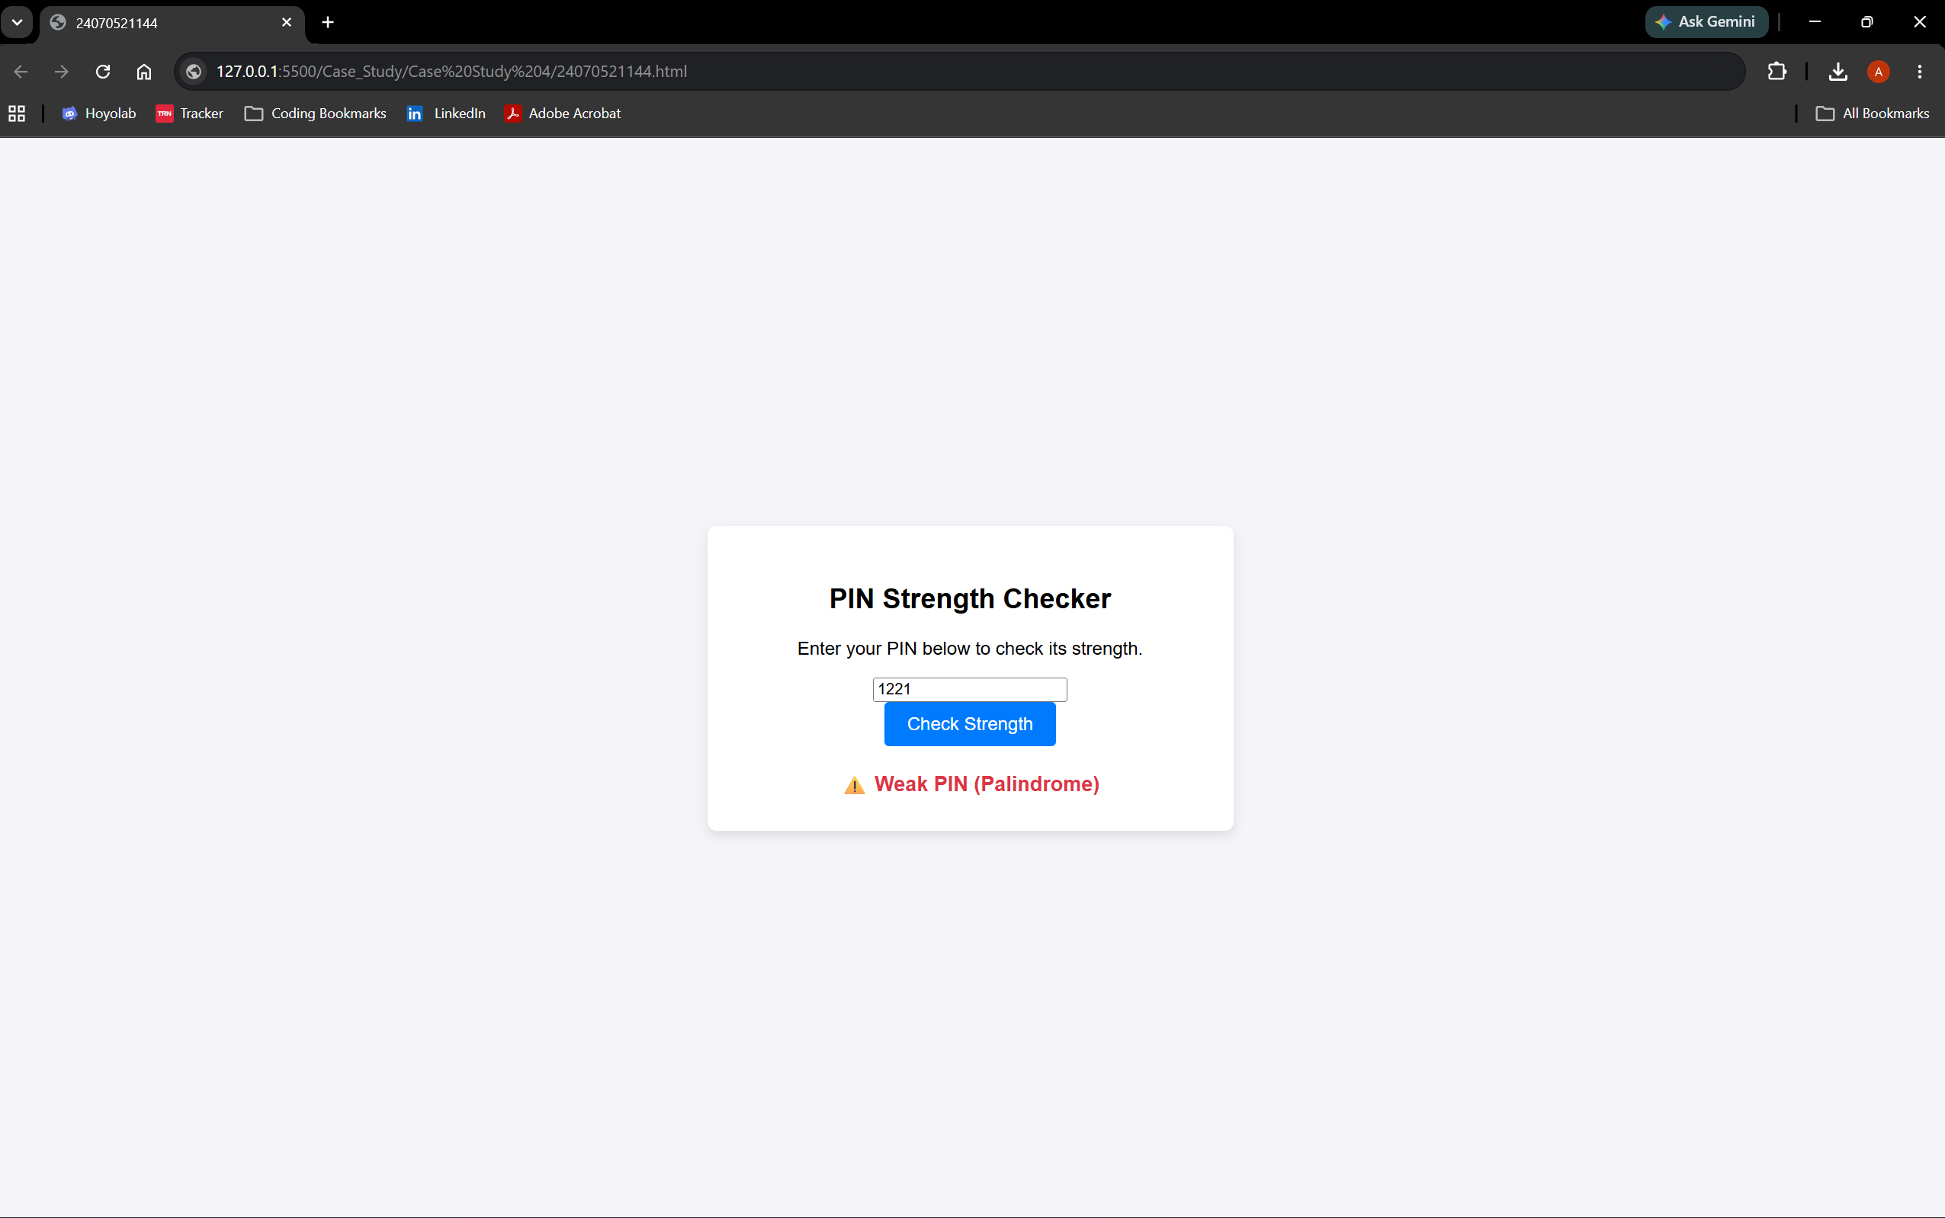

Result: Successfully implemented a ATM pin Palindrome detector using JavaScript ES6 features, including var, let, const, template literals, and destructuring, to find and display whether the given ATM pin is a palindrome or not.

